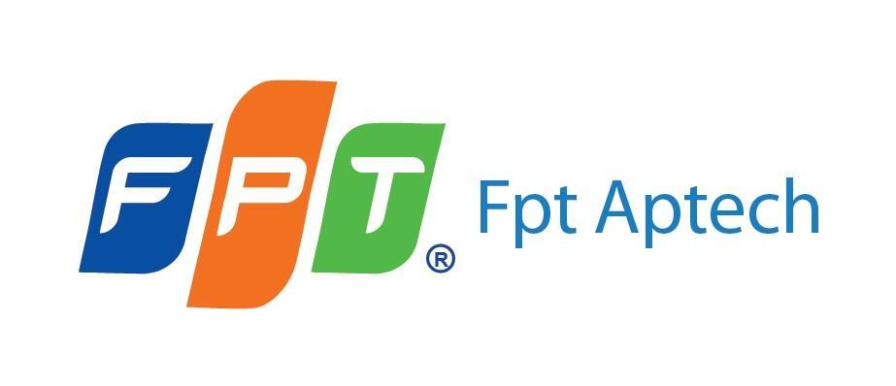 

|  |
| --- |
| **FPT - APTECH COMPUTER EDUCATION** |
| Project Report |
| Android movie streaming app |
| App Name: NetFilm + |
| |  |  | | --- | --- | | **Group 1** | | | **Group members** | Nguyễn Hoàng Sơn – Back-end, Leader  Phạm Đức Mạnh - Android  Bùi Văn Sinh - Android  Nguyễn Hữu Thành – Front-end, Deploy  Đặng Tuấn Sơn - Tester | | **Batch** | T1911E | | **Center** | FPT Aptech | | **Semester** | 4 | |
|  |

|  |
| --- |
| - Hanoi, 3/2022 - |

**Contents**

1. Introduction 3

2. About our Product 3

2.1. Reasons 3

2.2. Technologies Used 3

2.3. Main Functionalities 4

3. Business Flow and Diagrams 5

3.1. Use Case Diagram 5

3.2. Activity Diagram 6

4. System Design Diagrams 9

4.1. Class Diagram 9

4.2. Sequence Diagram 11

4.3. E.R.D/ Database Diagram 16

5. Screenshots 17

5.1 Android App 17

5.2 Web App for Admin 28

# Introduction

* Netfilm+ is an upcoming movie streaming platform developed by a small 5-person team aims to provide high quality HD movies to the customers via an app on Android.
* This application was made to serve the purpose of providing a cheap and convenient solution for movie streaming platform. An alternative to Netflix, HBO max, Hulu, Disney+,….

# About our Product

## Reasons

The reasons we made this app are as follow:

- The streaming market is booming thanks to its convenience and wealth of contents.

- Current offering by foreign competitors is still too expensive

- We want to create a streaming service that can compete on both quality and pricing front

## Technologies Used

The Technologies we used are as follow:

- Spring Boot: A framework written in Java, for creating back-end APIs.

- Vue.js: A front-end UI web framework, for creating web UI for admin page.

- Android: Using android studio, written in Java, for creating application UI on android.

- MySQL, as our main database management system.

- Cloud VPS and NGINX, for deploying the web application to a server.

## Main Functionalities

2.3.1 The Android application should hold the following functionalities:

- Have Login and Register Functionalities. New User must register. A registered user can log onto the app.

- In Home Page user will see some list movies, sorted by categories such as trending, hot, action,…

- In Library Page, user can see list of all movies, on top of that user can also touch on one of the list category above to see movies sorted by that category.

- User can search for a specific movie.

- In Detail Page, User can touch the play button to watch movie. Also user can add a movie to favorite and share the link of the app on google play store. User can also access other list movies sorted by casts, directors, or categories by touching their name under the movie description. User can also watch another movie from “Other Movies” list.

- User can buy a subscription package using their registered credit card on their Google Play. After that, user can access premium contents such as premium movies,…

2.3.2 Admin Web page should hold the following functionalities:

- Admin login function.

- Dashboard, showing an overview of statistics such as revenues, number of users, number of items,…

- Create, Read, Edit, Update, Soft Delete for all data such as movies, categories, casts, directors,…

- Search functionality, allow admin to search items by different criteria.

- Show online updates and notifications for each new subscriber and payment received. Also show a table of recent revenue stream.

# Use Case Diagrams and Business Flows

## Use Case Diagram

***3.1.1 Use use case:***

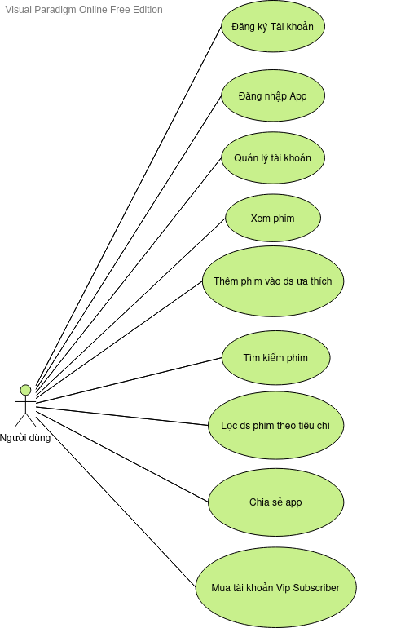

***3.1.2 Admin use case:***

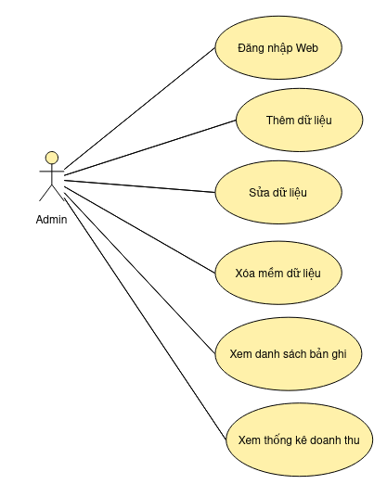

## Activity Diagram

***3.2.1 User login activity (Android App):***

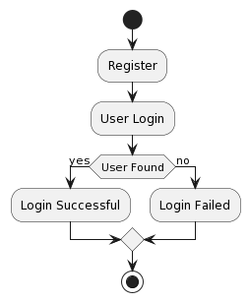

***3.2.2 Main activities (Android App):***

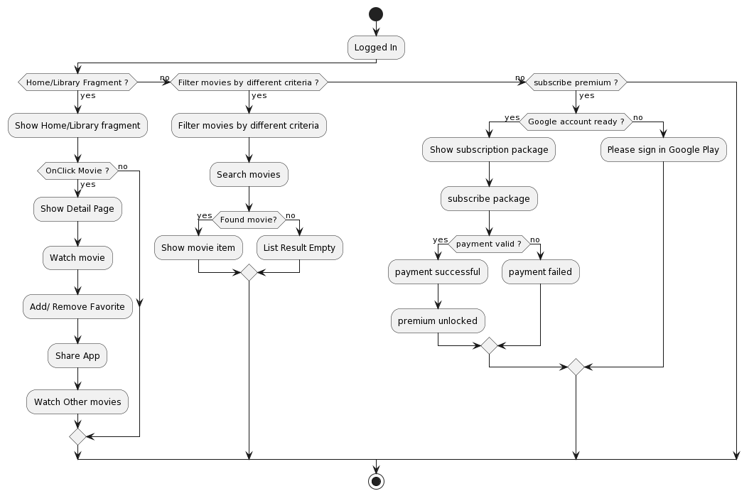

***3.2.3 Admin activities (Web):***

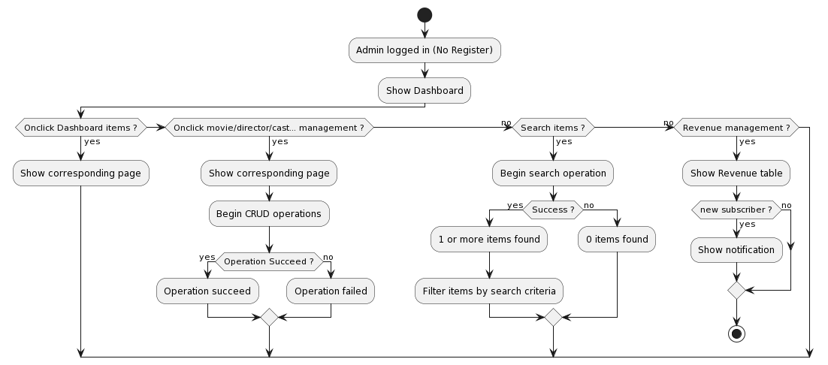

# System Design

## Class Diagram

***4.1.1. Admin System:***

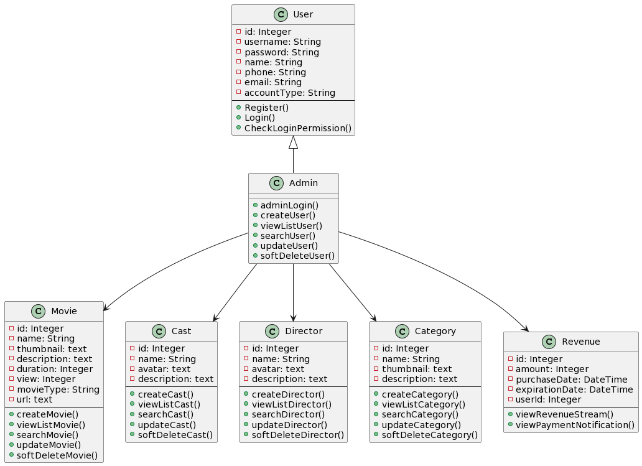

***4.1.2. End-user System:***

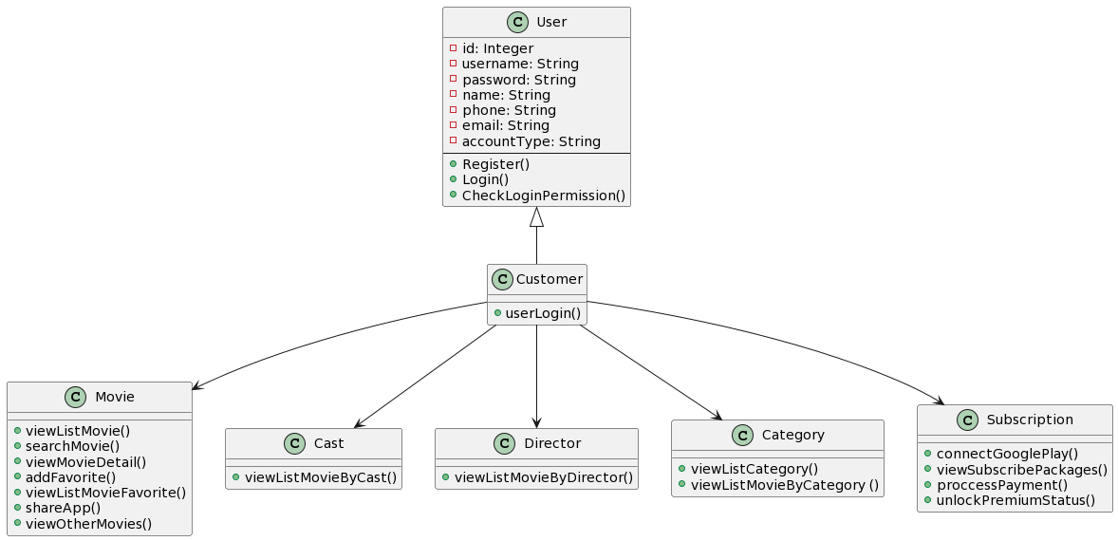

## Sequence Diagram

***4.2.1 Login and Register (For Customer):***

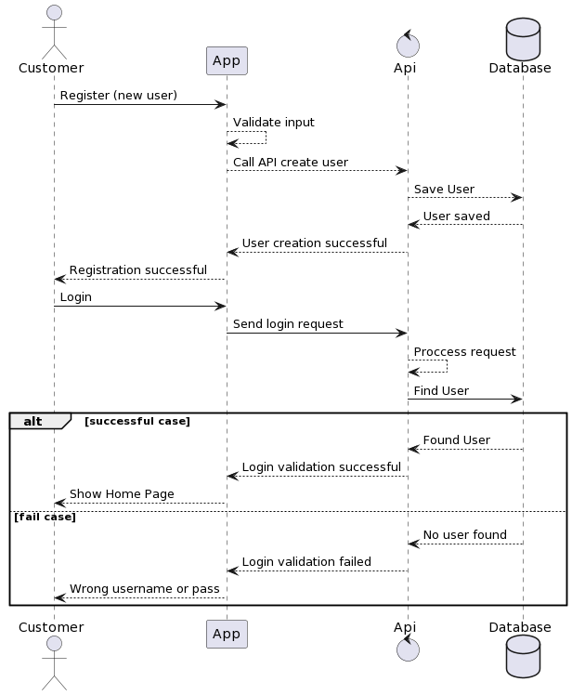

***4.2.2 Main flow (For Customer):***

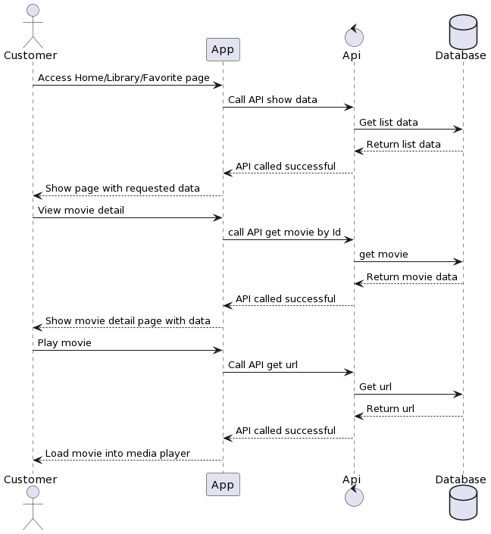

***4.2.3 Subscribe premium flow (For Customer):***

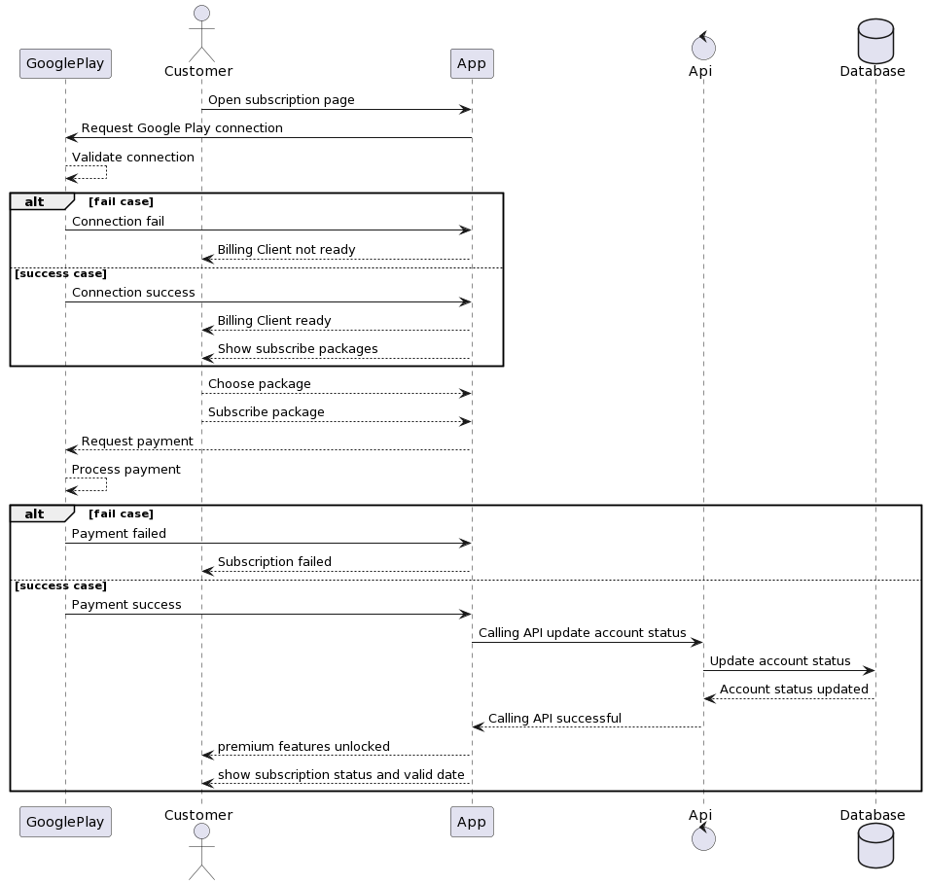

***4.2.4 Admin Login and Create:***

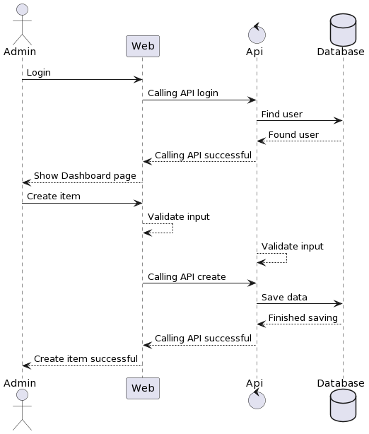

***4.2.5 Admin Update/Search/Delete:***

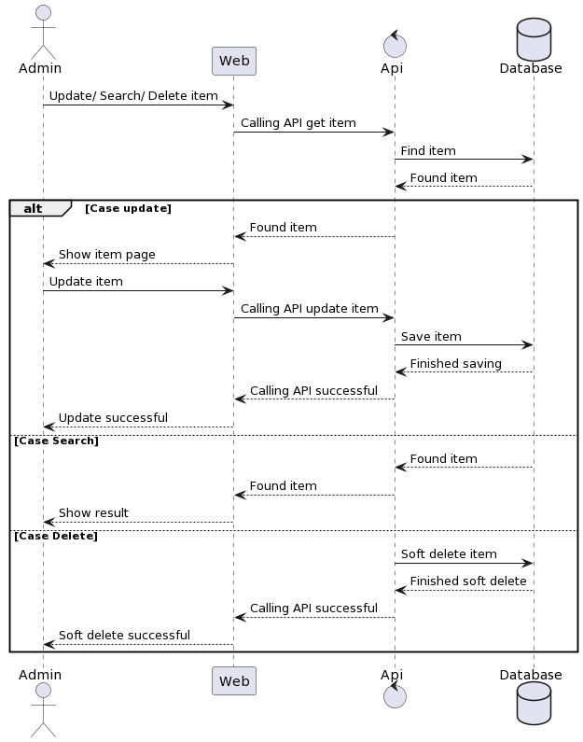

## Entity Relationship Diagram/ Database Design

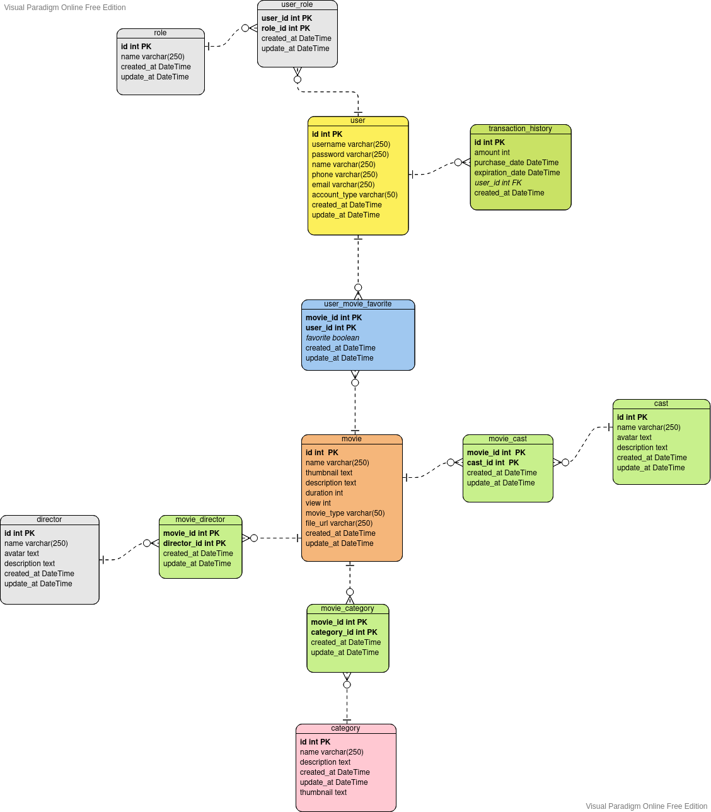

**5 Screenshots**

## 5.1 Android App:

***5.1.1. Splash screen:***

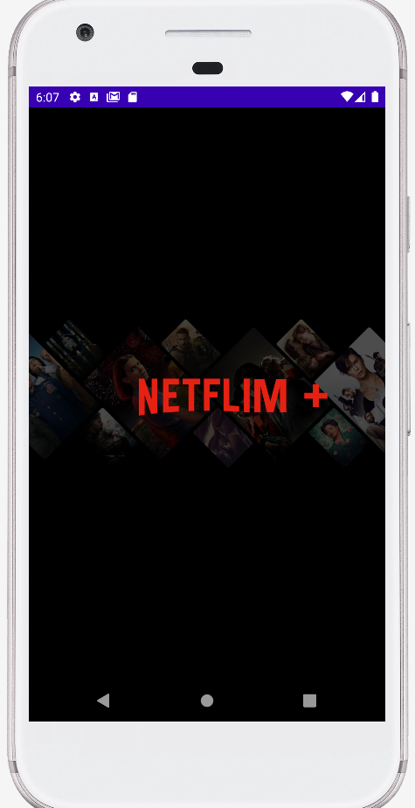

***5.1.2. Register and Login:***

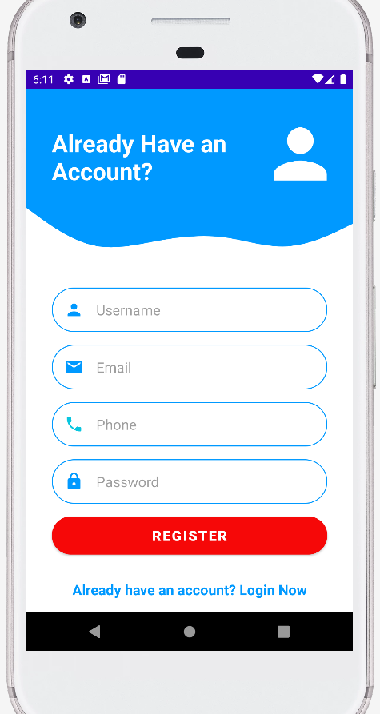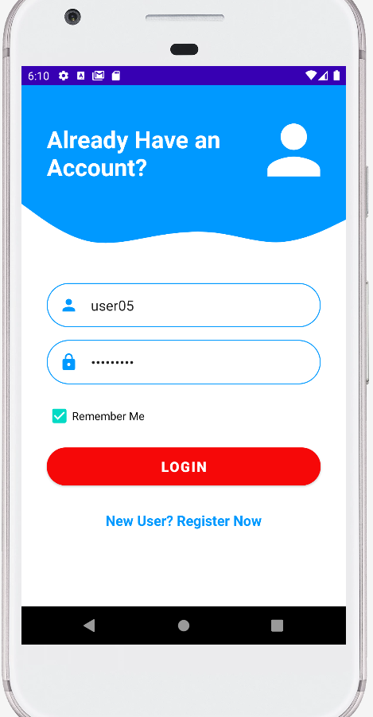

***5.1.3. Home Screen:***

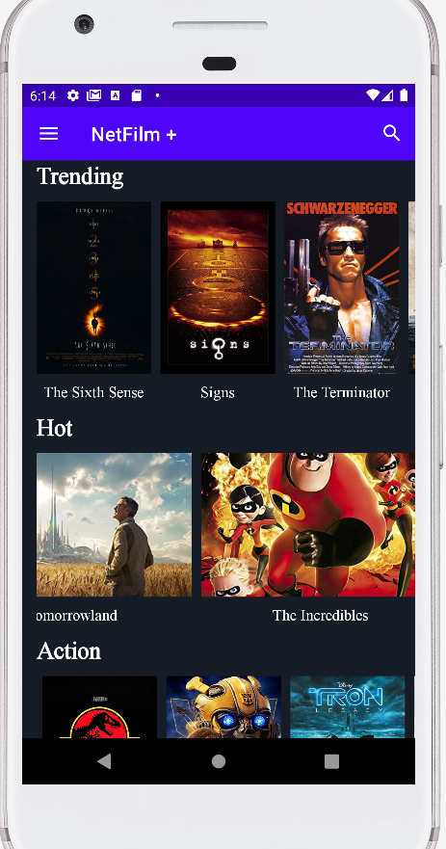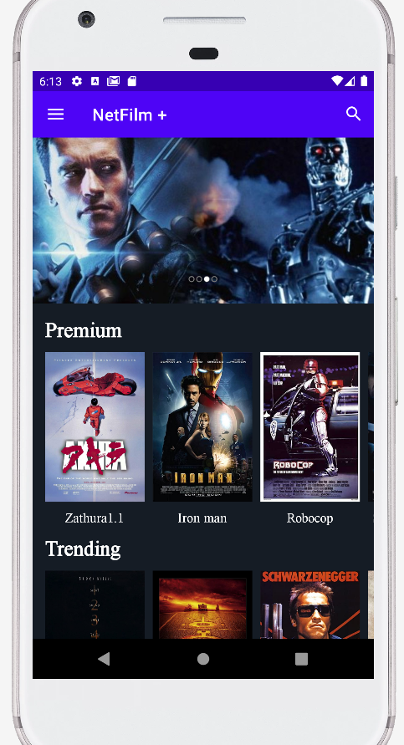

***5.1.4. Menu screen:***

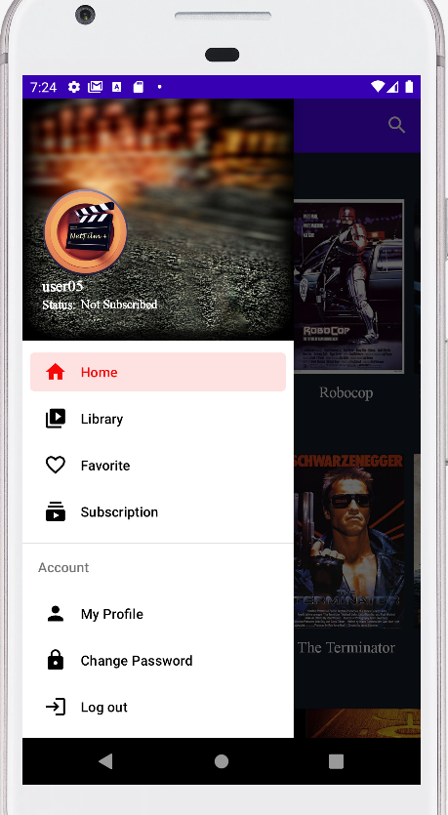

***5.1.5. Library screen:***

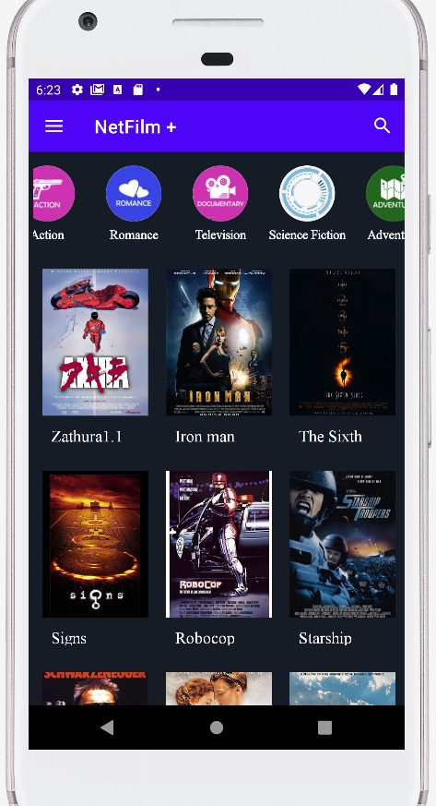

***5.1.6. List movies sorted by category or cast:***

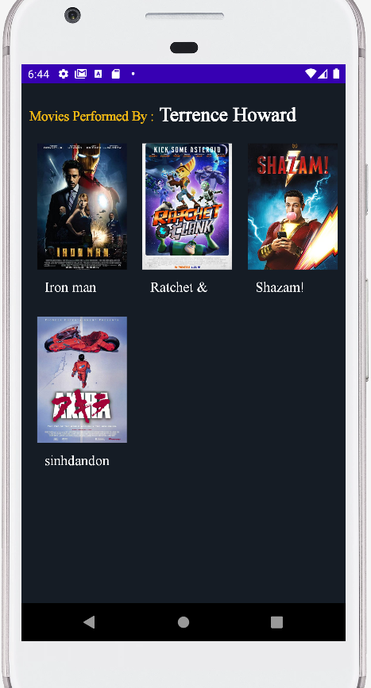

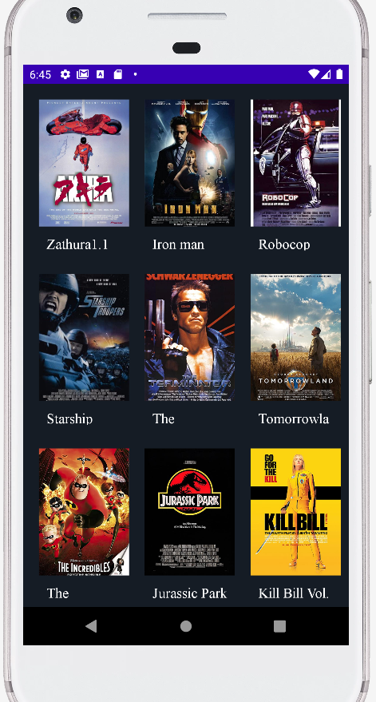

***5.1.7. List favorite/ search screens:***

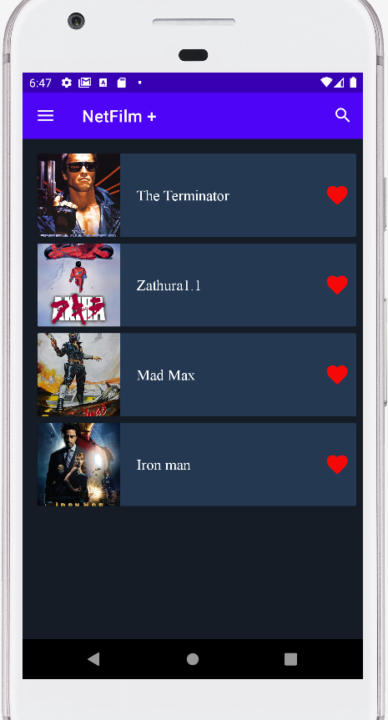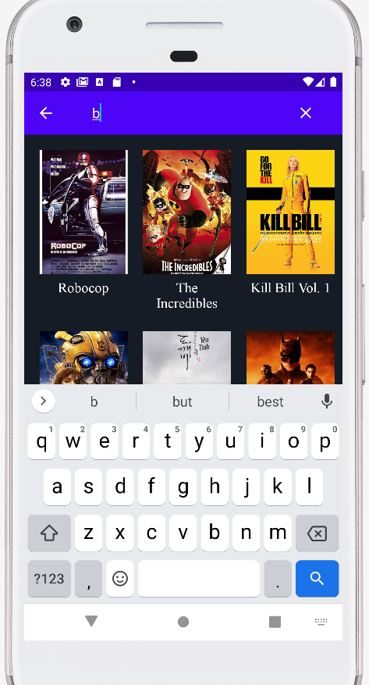

***5.1.8. Movie Detail & Media Player screen:***

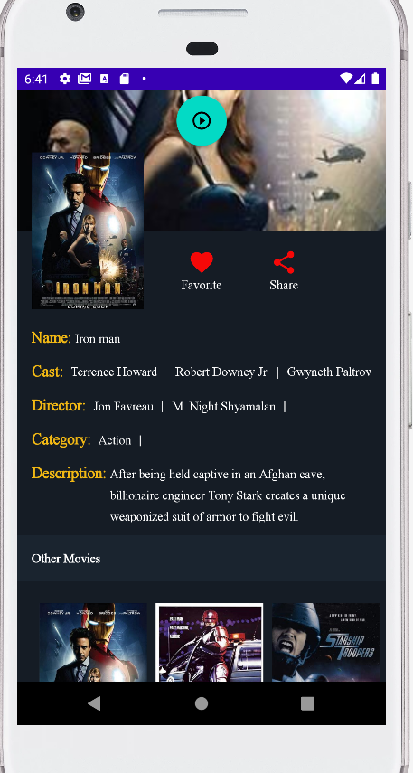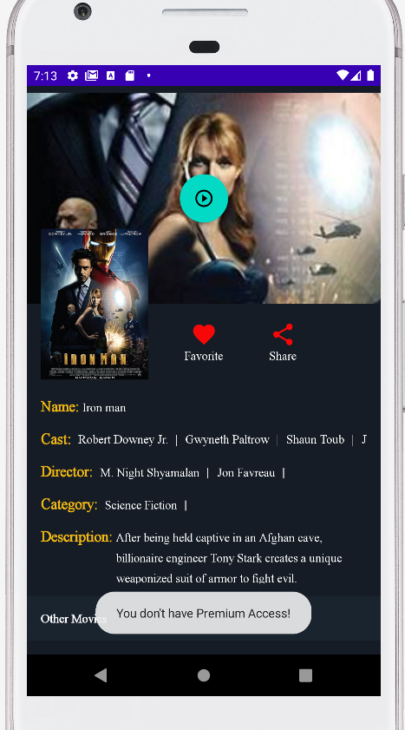

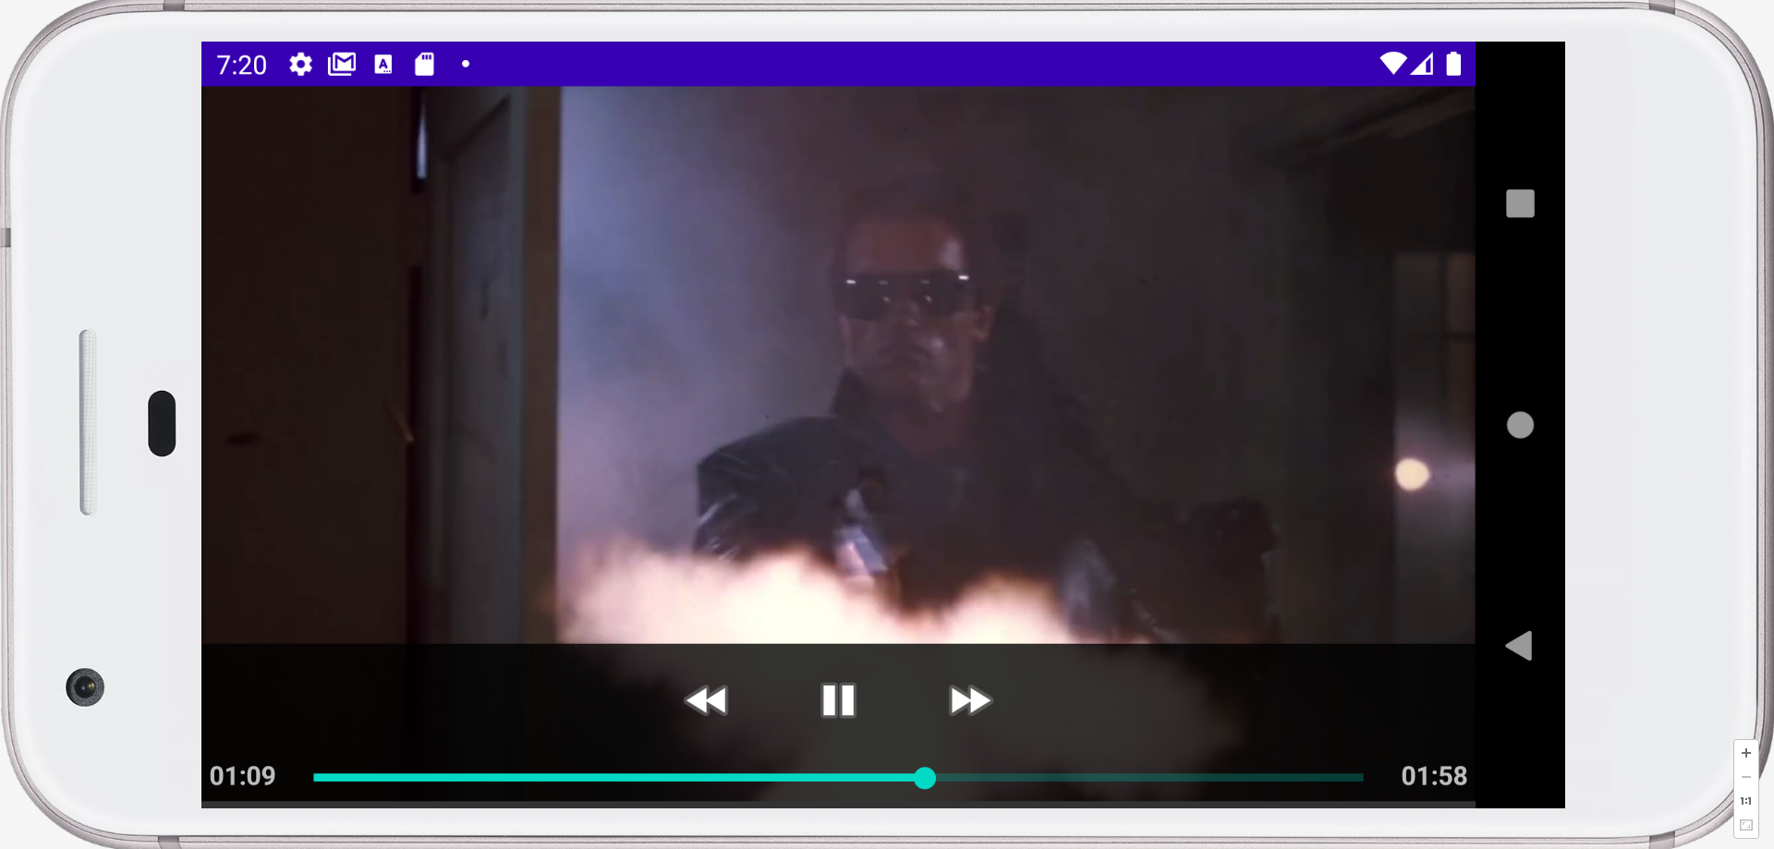

***5.1.9. Share App:***

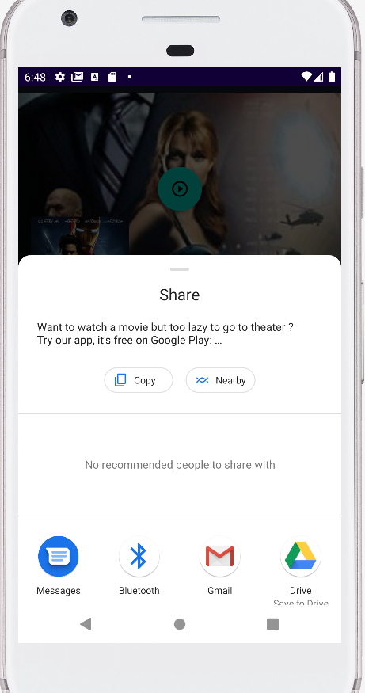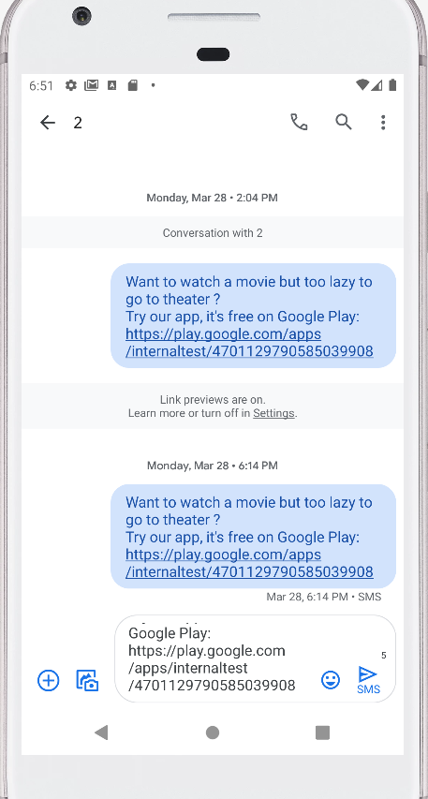

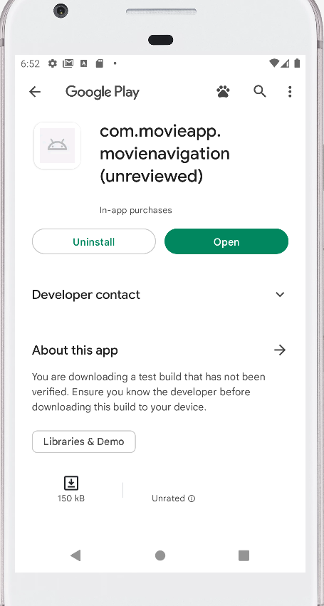

***5.1.10. Premium Subscription Screens:***

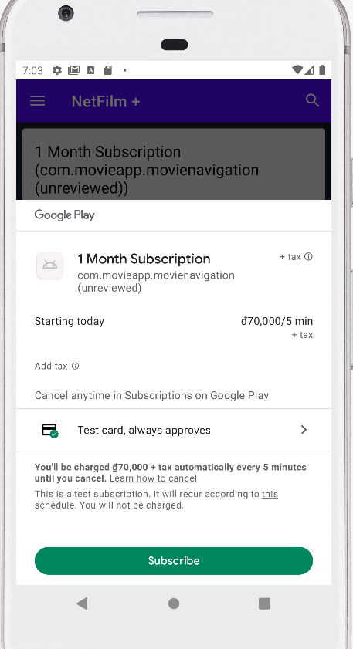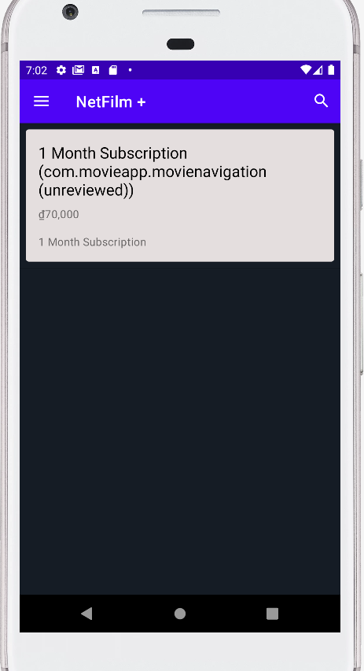

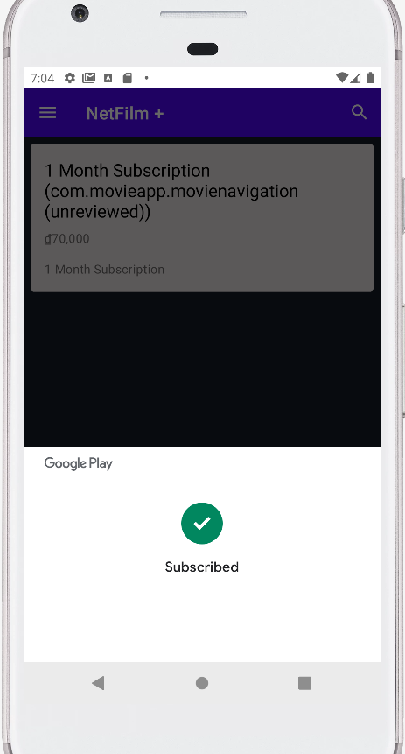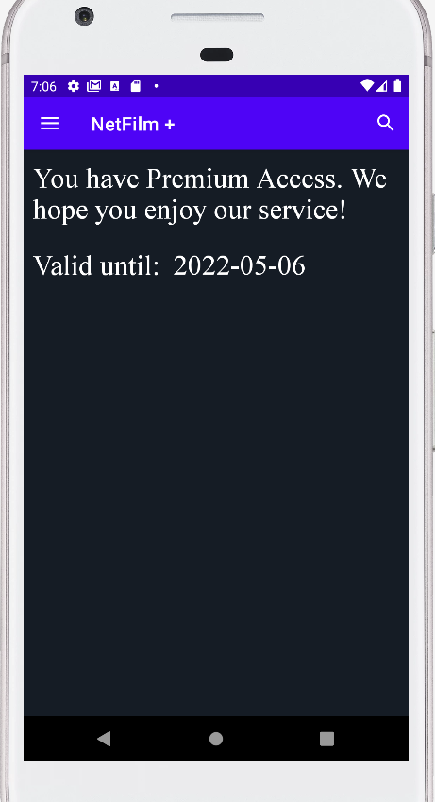

## 5.2 Web App for Admin:

***5.2.1. Dashboard:***

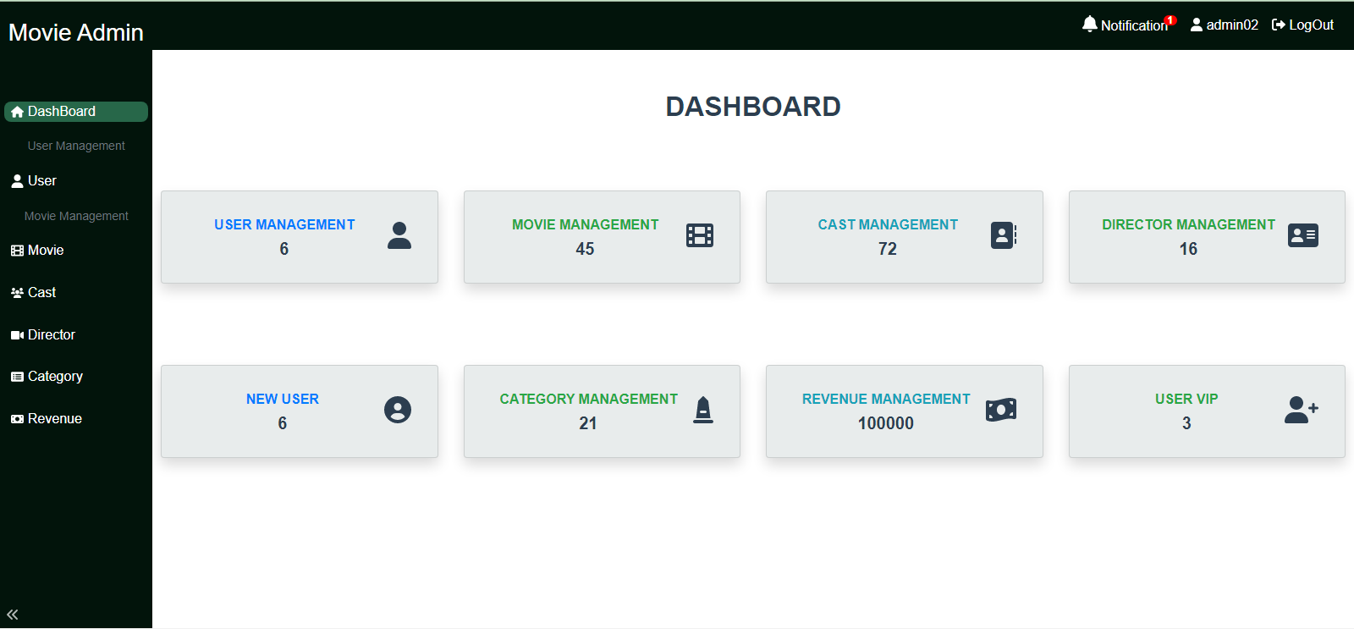

***5.2.2. Movies Management page:***

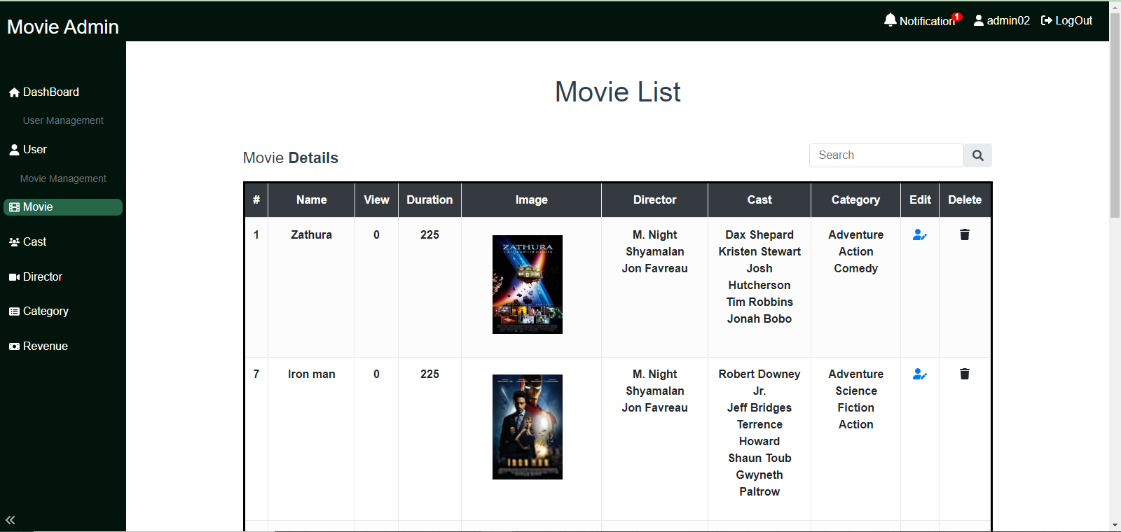

***5.2.3. Categories Management page:***

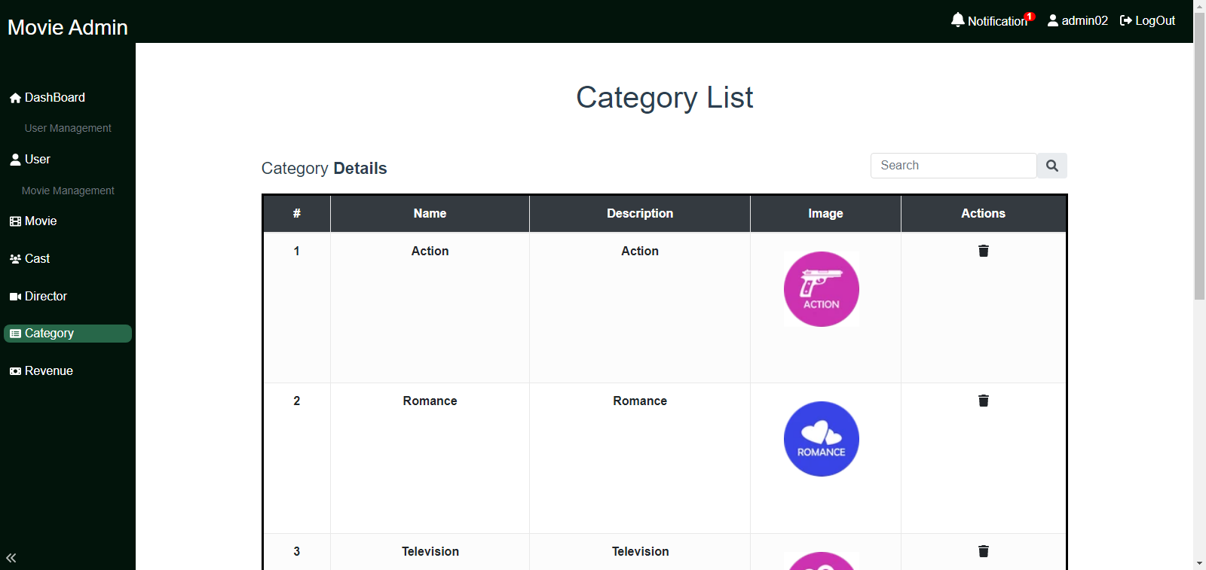

***5.2.4. Casts Management page:***

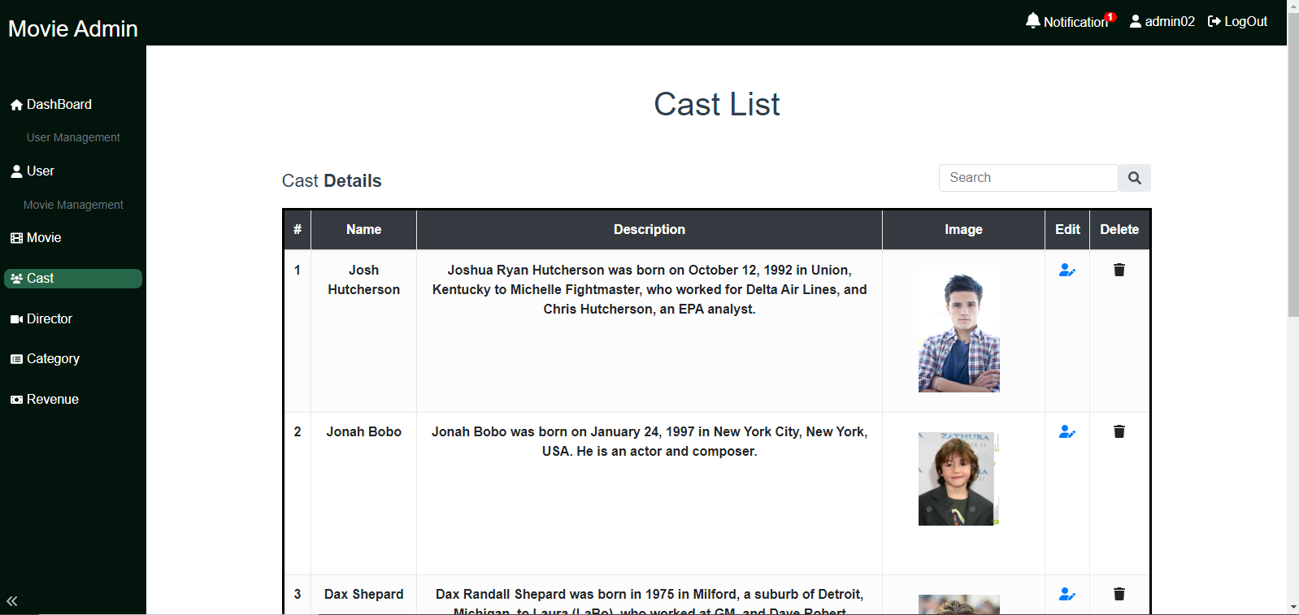

***5.2.5. Directors Management page:***

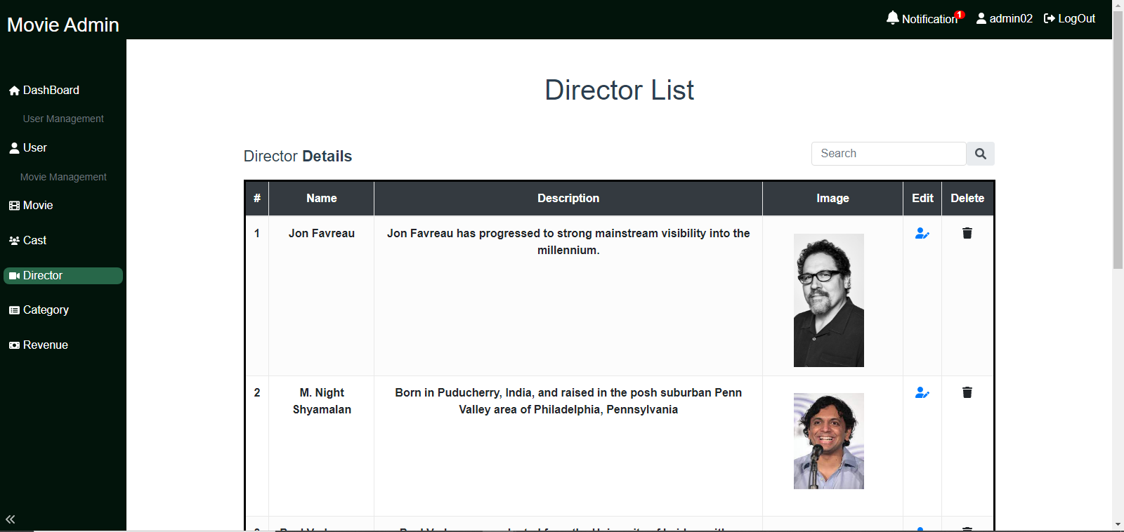

***5.2.6. Users Management page:***

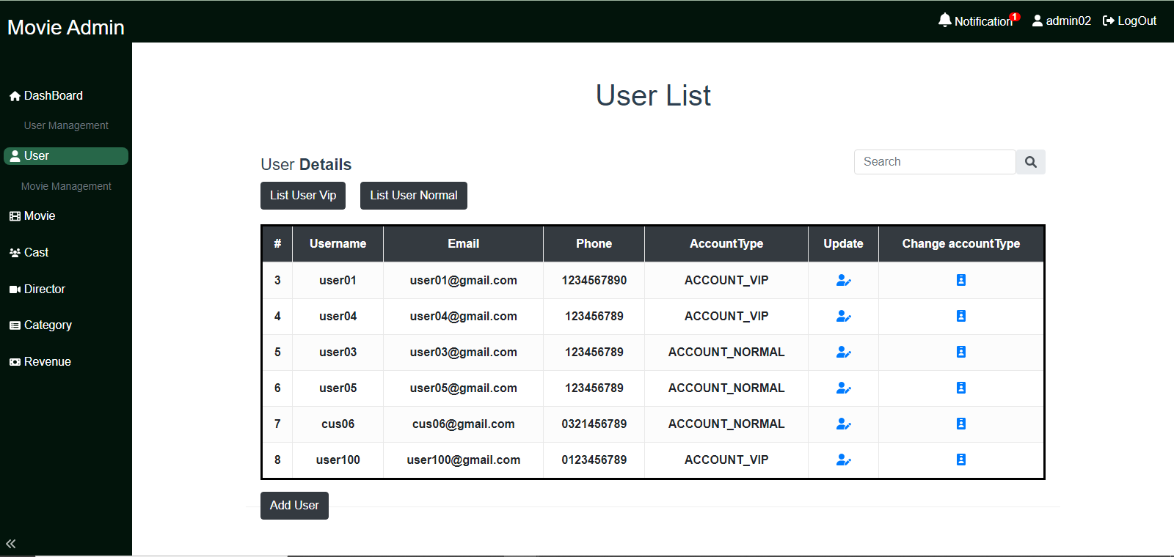

***5.2.7. Revenue Reports Page:***

